CLEANING PROCEDURES

Anything beyond a normal cleaning will result in additional charges.
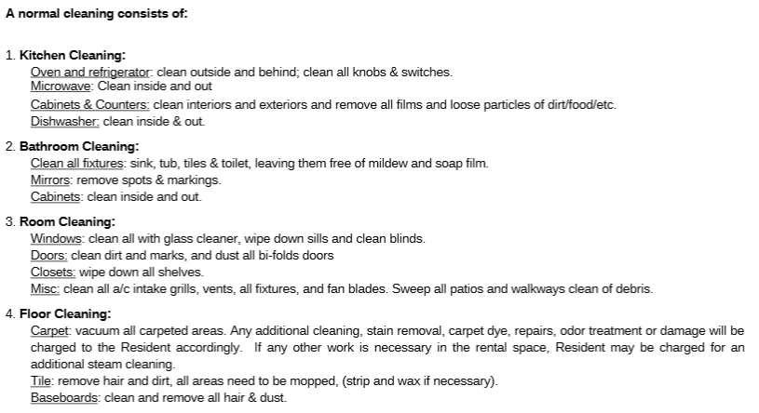

The RESIDENT is responsible for cleaning any item or appliance not listed above. Any items excessively dirty, stained or if any cleaning is not considered normal cleaning, the resident will be charged.

ANY personal property which remains in the property or in the rental space after the resident has vacated shall be considered abandoned and will be removed at the resident cost: $25 per item, $85 per large item, and $25 per trash bag.

CHARGE LIST
**All Charges Represent an Estimate.
Cost varies based on supplier & condition of furniture.

Cleaning Costs
Living Room Cleaning |  | $100
Kitchen
Oven |  | $ 50.00
Fridge |  | $ 25.00
Cabinets |  | $ 25.00
Counter Tops |  | $ 10.00
Floor |  | $ 10.00
Sink |  | $ 10.00
Full Kitchen Clean |  | $ 150.00
Laundry Room
Dryer (including lint trap) |  | $ 15.00
Washing Machine |  | $ 15.00
Full Laundry Clean |  | $ 30.00
Bedroom
Ceiling Fan |  | $8
Blinds |  | $15
Baseboards |  | $15
Furniture |  | $25
Full Bedroom Clean |  | $100
Bath
Toilet |  | $ 10.00
Tub/Shower |  | $ 20.00
Sink |  | $ 10.00
Cabinets/Vanity |  | $ 10.00
Floor |  | $ 15.00
Full Bath Clean |  | $ 85.00

Flooring Costs
Landing/Hallway | $TBD
Small Carpet Stain Removal | $25.00
Large Carpet Stain Removal | $50.00
Ozone Treatment | $100 per day
Subfloor Treatment | $250.00
Carpet Repair/Replacement
Replacement Per Bedroom | $350-450
Replace Hallway/Landing | $TBD
Stretch Carpet | $TBD
Laminate Floor Replacement
Living room | $TBD
Kitchen | $TBD
Walls
Curtain Rod Removal & Patch | $ 35.00
Anchor hole patch & repair | $ 15.00
Holes through wall (<1’x1’) | $ 65.00
Holes through wall (>1’x1’) | $ 150.00
Closet/Laundry Shelf | $ 50.00
Doorknob Hole Repair | $ 80.00
Fist Hole Repair | $ 80.00
Dart Board | $ 120.00

Paint Costs
Full Unit Paint | $300-700
Single bedroom | $250
Painting One Bathroom | $75
Painting Trim Throughout | $50
Painting Ceiling Per Room | $50
Painting Common Areas Only | $150
Sticky Tape | $ 55.00
Bed Rub | $ 60.00
Excessive Scuffs on Walls | $ 25.00
Windows (Replacements)
Windows | $ 250.00
Regular Blinds | $ 25.00
Back Door Blinds | $ 50.00
Plantation Blinds | $ 50.00
Mini-Blind Twist Rod | $ 10.00
Bedroom Screen | $ 35.00
Doors & Locks (Replacements)
Interior Door Frame replacement | $ 200.00
Interior Door | $ 150.00
Front door lock replacement | $ 75.00
Bedroom door lock replacement | $ 55.00
Doorknob replacement | $ 50.00
Front door replacement | $ 450.00
Doorstops | $ 5.00
Sand/Stain/Refinish Wood Door | $ 150.00
**All Charges Represent an Estimate. Cost varies based on supplier & condition of furniture

Bath (Replacement Costs)
Cabinet | $ 300.00
Shower Head | $ 25.00
Towel Rack Rod | $ 15.00
Towel Rack Holder | $ 45.00
Toilet Seat | $ 35.00
Tank Lid | $ 125.00
Complete Toilet Replacement | $ 350.00
Bath Vanity | $ 200.00
Mirror | $ 100.00
Faucet | $ 55.00
Shower Knob | $ 25.00
Sink Stopper | $ 25.00
Tub Stopper | $ 15.00
Kitchen (Replacement Costs)
Faucet | $ 80.00
Disposal | $ 90.00
Refrigerator | $ 600.00
Microwave | $ 325.00
Kitchen Sink | $ 125.00
Oven | $ 450.00
Dishwasher | $ 350.00
Ice Maker | $ 110.00
Crisper shelf in refrigerator | $ 45.00
Oven door replacement | $ 100.00
Microwave door | $ 65.00
Microwave Tray or receptacle | $ 35.00
Refrigerator handle | $ 35.00
Oven door handle | $ 35.00
Shelf retainers in refrigerator | $ 30.00
Cabinets | $ 1,400.00
Cabinet doors | $ 45.00
Drawer | $ 50.00
Burn in Countertop (per burn) | $ 35.00
Countertop Laminate Replaced | $ 200.00
Countertop Replacement | $ 600.00
Cabinet Door Pulls | $ 3.00

Living Room (Replacement Costs)
Ceiling Fan | $ 125.00
Smoke Detector (hard wired) | $ 45.00
Sprinkler Head | $ 200.00
Air Duct vent | $ 35.00
Pest Control Needed
Live Bugs | $ 100.00
Flea Treatment | $ 200.00
Lights & Globes
Interior Bulb | $ 2.00
Laundry Room Globe | $ 35.00
Ceiling Fan Light Globe | $ 35.00
Dining Room Globe | $ 35.00
Dining Room Light Fixture | $ 75.00
Kitchen Light Cover | $ 45.00
Bedroom Ceiling Fan/Light Fixture | $ 125.00
Bathroom Vanity Light Fixture | $ 100.00
Miscellaneous
Unit/Bedroom Key | $ 50.00
Mail Key | $ 25.00
Parking Decal (Reserved Parking) | $ 25.00
Gate Clicker | $ 50.00
Trash Removal (per bag) | $ 25.00
Pool Wristband | $125.00
Satellite Dish Removal | $ 150.00
Thermostat | $ 35.00
Switch replacement | $ 15.00
Outlet cover | $ 5.00
Washer | $ 525.00
Dryer | $ 550.00
Drip Pan Set | $ 20.00
Sprinkler Head | $ 50.00
Smoke Detector | $ 25.00

Furniture Replacement/ Repair Costs
3 Seat Couch | $500
2 Seat Couch | $480
Desk | $141
Desk Chair | $109
Lounge chair | $335
Bar Stool | $130 Per chair
Mattress | $229
Bed Frame | $160
Coffee Table | $125

Entertainment Center | $195
Dresser | $400
Kitchen Table | $189
Kitchen Chair | $109 Per chair
Flat Screen TV | $350

**All Charges Represent an Estimate. Cost varies based on supplier & condition of furniture

